This folder contains the MYTSBE package needed for formatting raw JTRAP data and PTAGIS data into the appropriate input for the multi-year time stratified hierarchical Bayesian models used in Oldemeyer et al 2016. A general schematic of workflow and functions:

**Data formatting**

CMR data file formatted for MYTSBE model function

**Models**

For Chinook

For Steelhead

JTRAP_Format merges information from the two data files and reformats into stratified CMR format needed for MYTSBE models

PTAGIS data needed for mark-recapture movement parameters

JTRAP data needed for daily capture, mark, recapture (CMR) data

**Data formatting**

*JTRAP data query*

The JTRAP data query is pretty straight forward. Query all the data at the rotary screw trap of interest (or just for the species of interest). The data needs to include columns with:

* Species name (column titled “**SpName**”)
* JTRAP Disposition acronym (column titled “**Disposition_Acronym**”)
* Date (column titled “**PT2Date**”)
* Number of fish (column titled “**NFish**”)
* Brood year (column titled “**BroodYr**”)

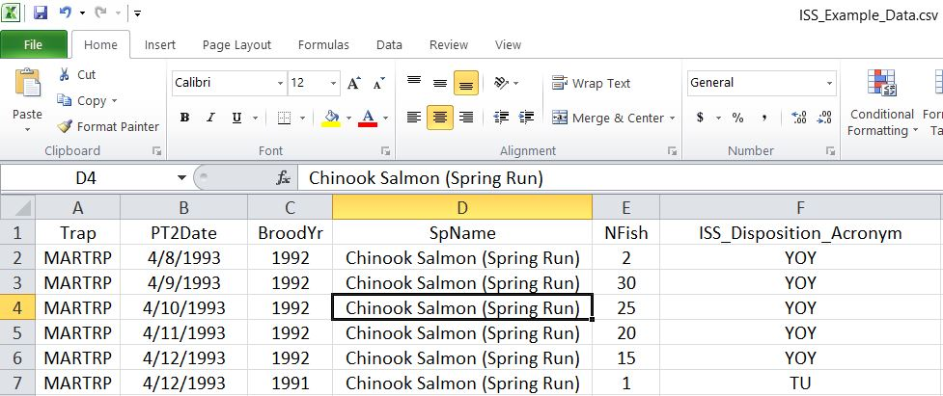Look at the “JTRAP_Example_Data.csv” file in this folder for an example.

Note:

* “JTRAP_Example_Data.csv” file includes columns “Trap”, “Operation”, etc. Having additional columns will NOT affect the formatting as long as there are five columns with the headers “SpName”, “Disposition_Acronym”, “PT2Date”, “BroodYr”, and “NFish”.
* The “Disposition_Acronym” column needs to have acronyms in standard “TU”, “TD”, “RE RC”, “NTT”, “NTR”, “NTS”, “RE BY”, “BBY, “NTD”, “YOY” format.

*PTAGIS data query*

Here are instructions to get the PTAGIS data needed for formatting.

* Go to <http://www.ptagis.org/data/advanced-reporting>
* Log in (you will need to create an account if you haven’t already)

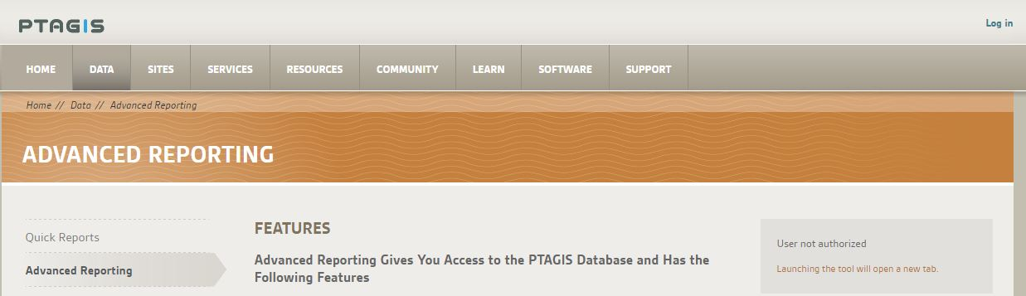

* Launch the advanced reporting

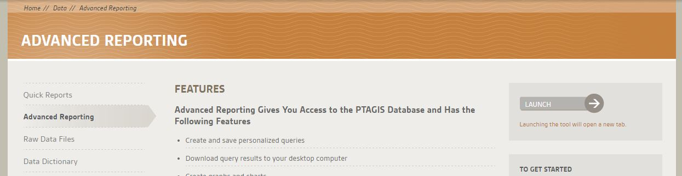

* 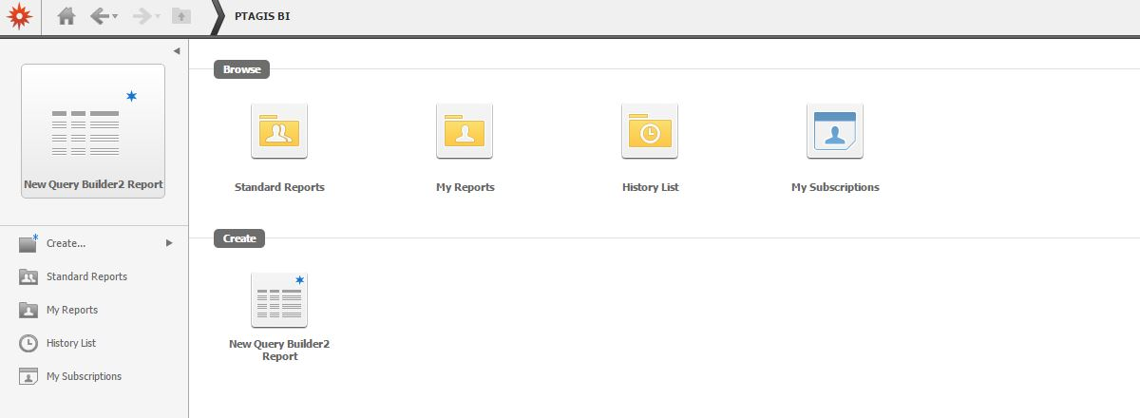Click on “New Query Builder2”
* Click on “Recapture Detail”

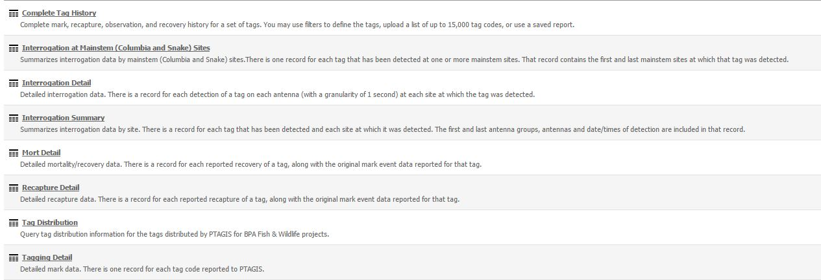

* Specify “Selected Attributes” to have at LEAST
  + “**Tag**”
  + “**Mark Date**”
  + “**Recap Date**”
  + NOTE: Additional selections aren’t necessary but won’t affect the formatting
* Specify “Release Site” to the screw trap of interest
* Specify “Recap Capture Method” to “Screw Trap”
* Specify “Recap Release Site” to the screw trap of interest
* Specify “Species” to the species of interest
  + NOTE: queries should only have one species selected.

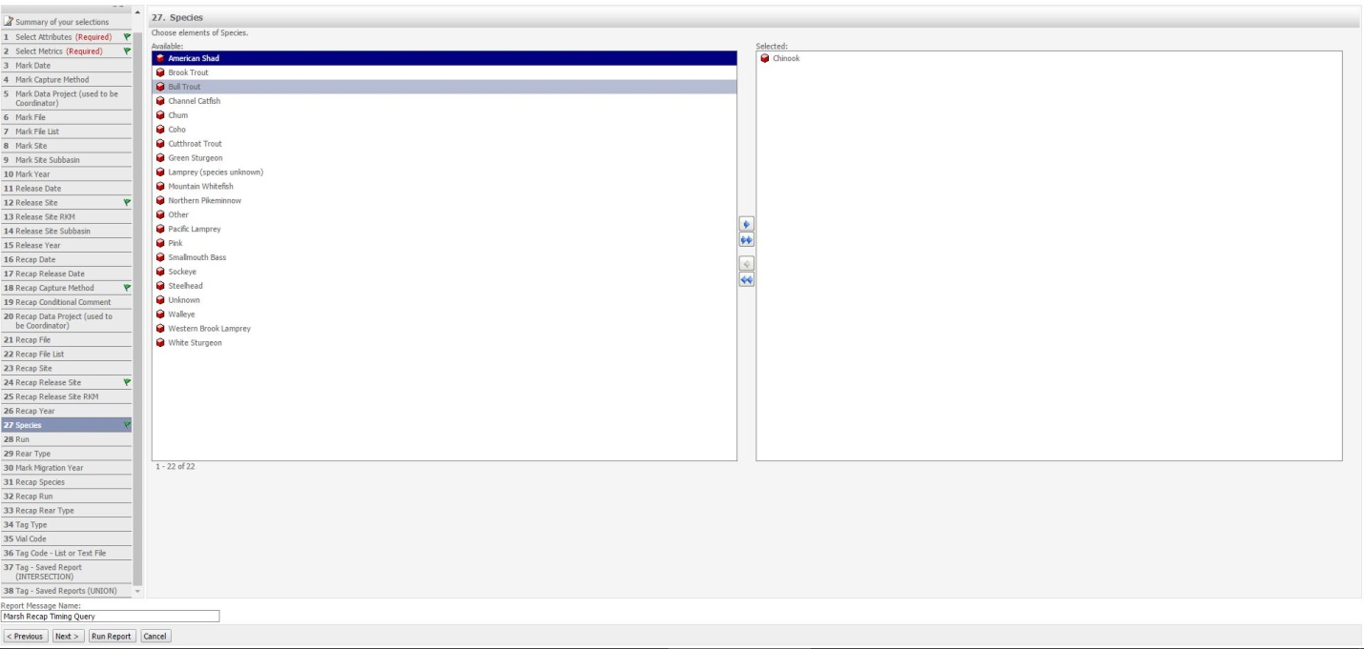

* Run report
* Export the report in CSV file format (Home>Export>CSV file format)

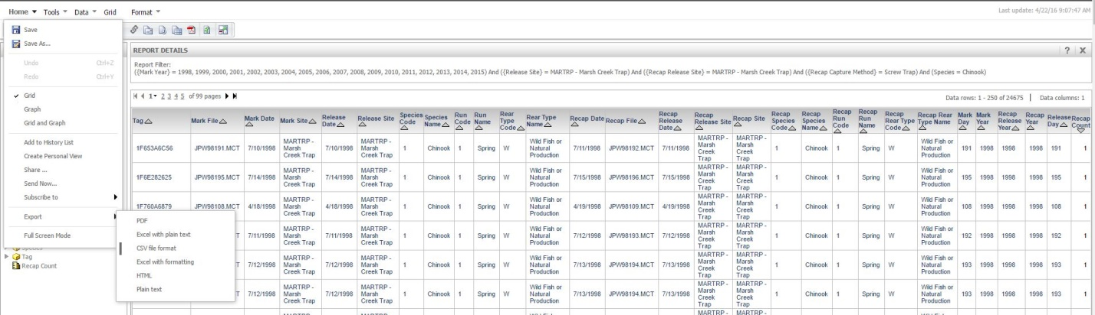

* Click the “Export” button in the next screen
* Open the downloaded file to make sure there is a “**Tag Code**”, “**Mark Date MMDDYYYY**”, and “**Recap Date MMDDYYYY**” column

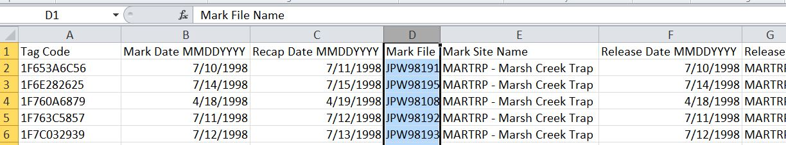

* Save or move the downloaded file to somewhere you won’t lose it.

**Modeling**

*Initial setup of Program R, RStudio, and JAGS*

* Download and install the Program R if you haven’t already
  + <https://cran.r-project.org/bin/windows/base/>
* Download and install RStudio if you haven’t already
  + <https://www.rstudio.com/products/rstudio/download/>
* Download and install JAGS if you haven’t already
  + <https://sourceforge.net/projects/mcmc-jags/>

*Merging and formatting JTRAP and PTAGIS using JTRAPFormat() function*

* Open RStudio
* Open file “MYTSBE_Template.R” located in this folder
* Follow the directions in the R script

*Steelhead*

* Continue to use the MYTSBE_Template.R and follow directions
* Use the function MYTSBE_Calendar() for steelhead

*Chinook*

* Continue to use the MYTSBE_Template.R and follow directions
* Use the function MYTSBE_Cohort() chinook